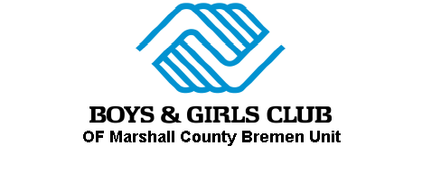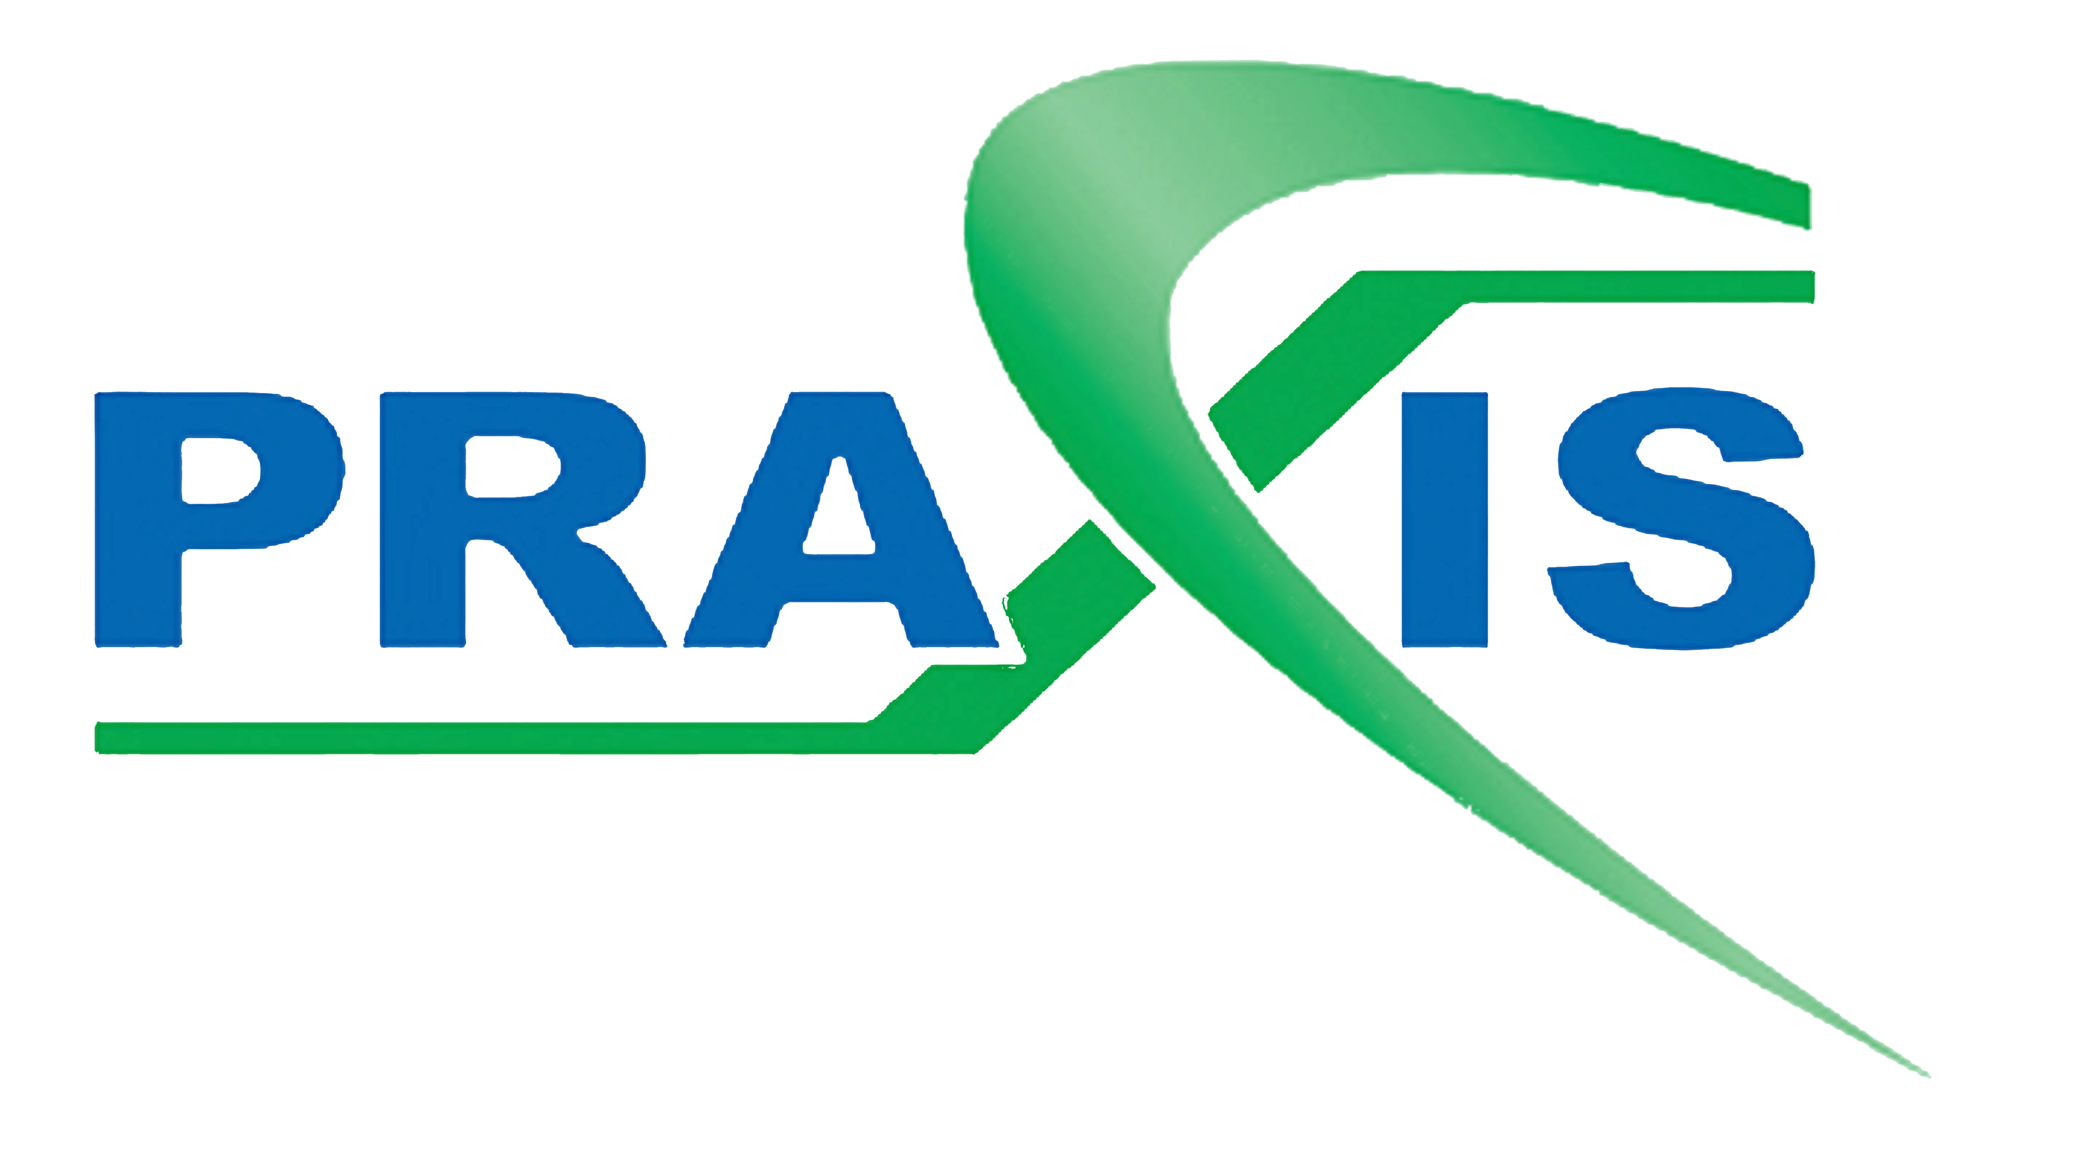
Cohort 9
Year 1
Prepared by:
Praxis Strategies & Solutions
Brad McLeish
President & CEO
bmcleish@praxisin.com
2018-2019 Annual Evaluation

Program Demographics & Attendance

Student Academic Achievement – Grades
Observations:
- The percentage of participants whose math grades declined is noteworthy. While its usual for grades to decline as courses get harder over the year, 39% is a bit high.
- Math achievement on standardized assessments show most participants are behind grade level to begin the year. Declines in math grades may be an artifact of the difficulty students face keeping up as concepts build on each other when they are already behind.
- Participants showed respectable growth in math and reading, meeting or exceeding typical annual progress, but most were well below grade level to begin the year and few reached grade level by the end of the year. Many will likely need multiple years of support to catch up to their peers. Retaining participants for multiple consecutive years should be a priority.

Student Academic Achievement – Assessments

Student Academic Achievement – Assessments

Student Social and Behavioral Learning
Observations:
The columns in green show students who teachers rated as not needing improvement. The other three columns for each question show the percentages of the remaining students who improved, declined, or did not change.

Large majorities of participants improved over the course of the year in nearly every category.

Family Engagement
Many of the center’s Hispanic participants are the children of undocumented workers. This population can be wary of certain institutions, are often poorly educated themselves, and are frequently unfamiliar with the function of the American education system. Building institutional trust within this population was a priority for the program, as was helping these parents learn how to help their children navigate an unfamiliar institution. | The program held regular workshops for parents to close this gap. Workshops were well attended. The program nearly doubled its goal for parent participation. On the end of year parent survey, nearly all respondents expressed some degree of confidence in their ability to help their children in school. Nearly all respondents also expressed a degree of institutional trust that the school and the afterschool program would look after the best interests of their children.

Performance Measures

Academic Measures
Outcome |  | Performance measure
8% |  | Spring proficiency rates on the English/Language Arts portion of NWEA will increase from fall proficiency rates each program year
27% |  | Spring proficiency rates on the math portion of NWEA will increase from fall proficiency rates each program year

Social/Behavioral Measures
Outcome |  | Performance measure
83% |  | 85% of regularly attending participants will attend at least 95% of school days.
64% |  | 50% of regularly attending participants who need improvement will show improved academic habits on the annual teacher survey

Family Engagement Measures
Outcome |  | Performance measure
97% |  | On the parent survey, 50% of parents will report regular communication with the program.
60% |  | 33% of parents of regularly attending participants will attend at least 1 parent workshop.

Renewability requirements
Outcome/
Points
0 |  | Program attendance
70% |  | 90% of projected number of RAPs attended across all program sites
70% |  | 75% of projected number of RAPs attended each site
5 |  | Performance Measures (Not required until year 3. For informational purposes only)
58% |  | At least 20% of RAPs show GROWTH in at least 2 Academic Performance Measures*
N/A** |  | at least 50% of RAPs show positive outcomes in at least 1 Social/Behavioral Performance Measures at all program sites.
*For growth we used the new performance measures which will be implemented in the 2019-20 school year.
**The new performance measures use new assessments which were not fielded this year, so no data was available for this requirement.

Conclusions & Recommendations
The BPS/Boys & Girls Club collaborative is a newly awarded center in cohort 9. The program design is well conceived, with certified teachers providing academic instruction and club staff providing organization and enrichment. The center employed an experience site coordinator who has run other 21st CCLCs in the past, and while some growing pains are to be expected, under her leadership the site organized quickly and responded effectively to the inevitable hiccups.

Club and school staff worked well together, and the close collaboration between the club and school meant they were far more effective in managing data collection and other administrative processes than other first-year programs who are still building those relationships. Club staff, many of whom are still in high school, were professional, well-trained and performed well above expectations for high school students. In the fall site visit, we observed an emerging program still tinkering with process and structure. By the spring visit, we observed a well-functioning organization which met all observable afterschool standards.

Academically, the center performed well in its first year. The center met all but one of its performance goals for the year, and participants made noteworthy growth in both reading and math. The center’s parent engagement efforts also yielded positive results, building institutional trust with the center’s migrant population and improving parents’ ability to support their children academically.

That said, there is still room for improvement. Many of the program’s participants started the year below grade level in reading and/or math, and only a few caught up by the end of the year. Nearly a third of participants didn’t make typical annual growth for the year on iReady assessments, meaning they fell farther behind. The center also fell short of its attendance goal for the year.

Recommendations:
Expand Recruiting/Retention: Most participants attended regularly, but with only 43 total participants they will need to recruit more broadly to make their goal going forward. Retaining students for multiple years should also be a priority. Participants showed respectable growth in math and reading, meeting or exceeding typical annual progress, but most were well below grade level to begin the year and very few reached grade level by the end of the year. Many will likely need multiple years of support to catch up to their peers.

Strengthen reading supports for LEP students: Nearly half the center’s participants are Limited English Proficiency students. While they showed noteworthy growth in math on par with their native English-speaking peers, growth in reading lagged behind. Nearly all LEP participants began the year below grade level in reading. Nearly half did not make typical annual growth, and only 1 in 4 met the stretch growth goal—the benchmark to catch up to their grade-level peers.

