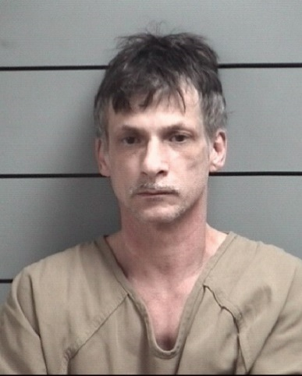
Anthony Long was arrested by UNIT Officers, assisted by Plymouth Police, after an investigation by the UNIT resulted in the issuance of a warrant for Dealing in Methamphetamine a Level 4 Felony $25,000 cash bond

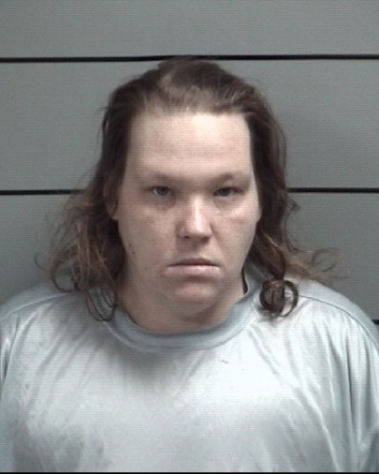
Rebecca McDonald was arrested by UNIT Officers, assisted by Plymouth Police, after a UNIT investigation resulted in the issuance of a warrant for Dealing in a Schedule I-III controlled substance a Level 4 Felony $25,000 cash bond

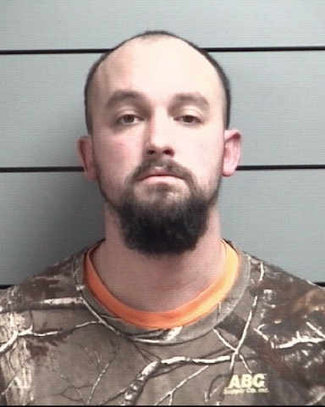
Christopher Boyne was arrested by UNIT Officers, assisted by Culver Police, after a UNIT investigation resulted in the issuance of a warrant for Dealing in Methamphetamine a Level 4 Felony $25,000 cash bond
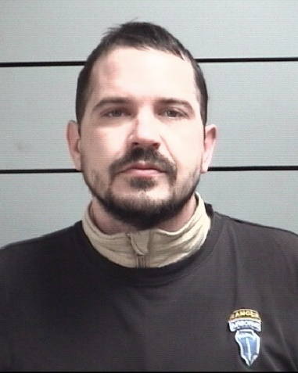
Patrick Leary was arrested by UNIT Officers, assisted by Plymouth Police, after a UNIT investigation resulted in the issuance of a warrant for Visiting a common nuisance B Misdemeanor. An additional case developed during his arrest for Possession of Methamphetamine.
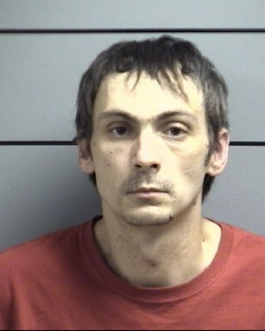
Uriah Milton was arrested by UNIT Officers, assisted by South Bend Police, after a UNIT investigation resulted in the issuance of a warrant for Dealing in Methamphetamine a Level 4 Felony $25,000 cash bond

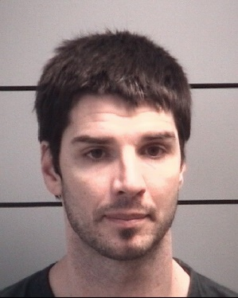
Aaron Egger was arrested by UNIT Officers, assisted by St. Joseph County, after a UNIT investigation resulted in the issuance of a warrant for Dealing in Methamphetamine a Level 4 Felony $25,000 cash bond
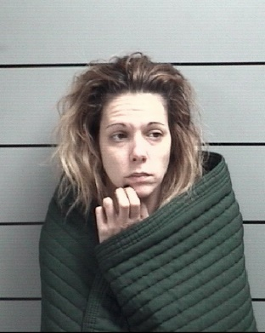
Ashley Bunton was arrested by UNIT Officers, assisted by South Bend Police, after a UNIT investigation resulted in the issuance of a warrant for Dealing in Methamphetamine a Level 4 Felony $25,000 cash bond
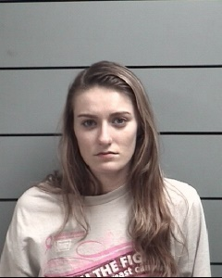
Justine Pittman-Bottorff was arrested by UNIT Officers, assisted by Plymouth Police, after a UNIT investigation resulted in the issuance of a warrant for Dealing in a Schedule I-III controlled substance a Level 3 Felony $25,000 cash bond

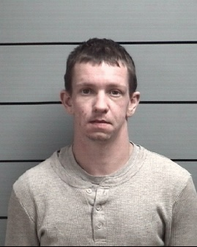
Chad Noah was arrested by UNIT Officers, assisted by Starke County Sheriff’s Department, after a UNIT investigation resulted in the issuance of a warrant for Dealing in Methamphetamine a Level 4 Felony $25,000 cash bond
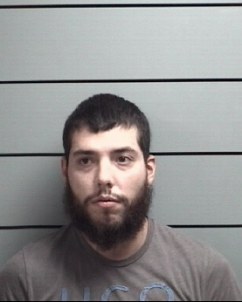
Joshua Costilla was arrested by UNIT Officers, assisted by Plymouth Police, after a UNIT investigation resulted in the issuance of a warrant for Dealing in a Look-a-like substance Level 6 Felony $10,000 cash bond. An additional case developed during his arrest for Dealing in Marijuana.
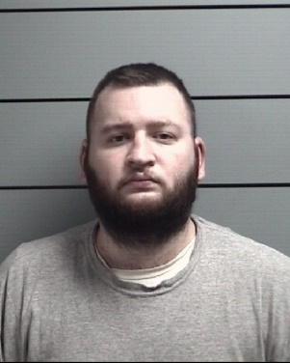
Brandyn Garbison was arrested by UNIT Officers, assisted by Starke County Sheriff’s Department, after a UNIT investigation resulted in the issuance of a warrant for Dealing in Cocaine or a Narcotic drug Level 6 Felony $10,000 cash bond

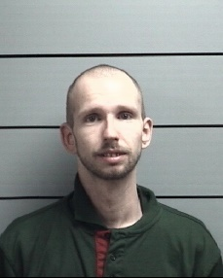
Jason Goad was arrested by UNIT Officers, assisted by Marshall County Police, after a UNIT investigation resulted in the issuance of a warrant for Dealing in Methamphetamine Level 5 Felony $25,000 cash bond
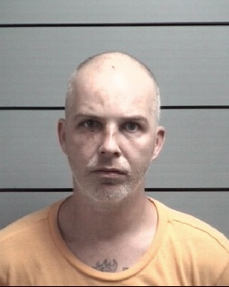
John Loftus was arrested by UNIT Officers, assisted by IDOC, after a UNIT investigation resulted in the issuance of a warrant for Dealing in Methamphetamine Level 4 Felony $25,000 cash bond
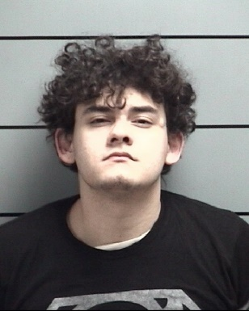
Alex Blanco was arrested by UNIT Officers, assisted by Pulaski County Sheriff, after a UNIT investigation resulted in the issuance of a warrant for Dealing in Cocaine Level 3 Felony $40,000 cash bond
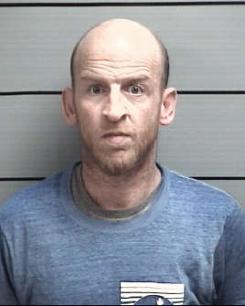
Matthew Schoff was arrested by UNIT Officers, assisted by Plymouth Police, after a UNIT investigation resulted in the issuance of a warrant for Dealing in Methamphetamine Level 4 Felony $25,000 cash bond

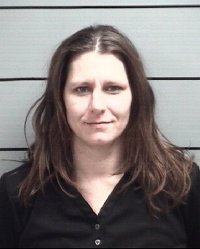
Nicole Dewitt was arrested by UNIT Officers, assisted by Plymouth Police, after a UNIT investigation resulted in the issuance of a warrant for Dealing in Methamphetamine Level 4 Felony $25,000 cash bond
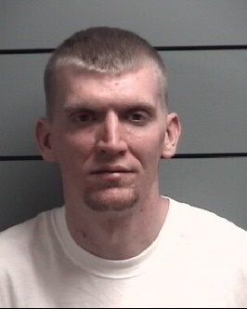
Adam Wagers was arrested by UNIT Officers, assisted by Starke County Sheriff, after a UNIT investigation resulted in the issuance of a warrant for Dealing in Methamphetamine Level 3 Felony $15,000 cash bond
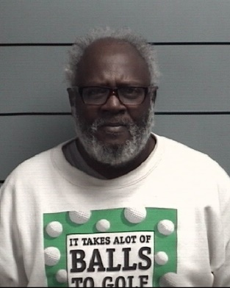
Otho Pulluaim Jr. was arrested by UNIT Officers, assisted by Starke County Sheriff, after a UNIT investigation resulted in the issuance of a warrant for Dealing in Schedule I-III controlled substance Level 4 Felony $25,000 cash bond

